**Higher Order Functions**

**MAP Method**

var animals = [

{ name: 'Castro' , species: 'rabbit' },

{ name: 'ibra' , species: 'dog' },

{ name: 'messi' , species: 'cat' },

{ name: 'cristiano' , species: 'goat' },

{ name: 'dybala' , species: 'bunny' }

]

// // for loop

var names = []

for (var i = 0; i < animals.length; i++) { names.push(animals[i].name) }

// Using map function

var names = animals.map( function (temp) { return temp.name })

// arrow functions only works on the ECHMASCRIPT6

var names = animals.map( (temp) => temp.name )

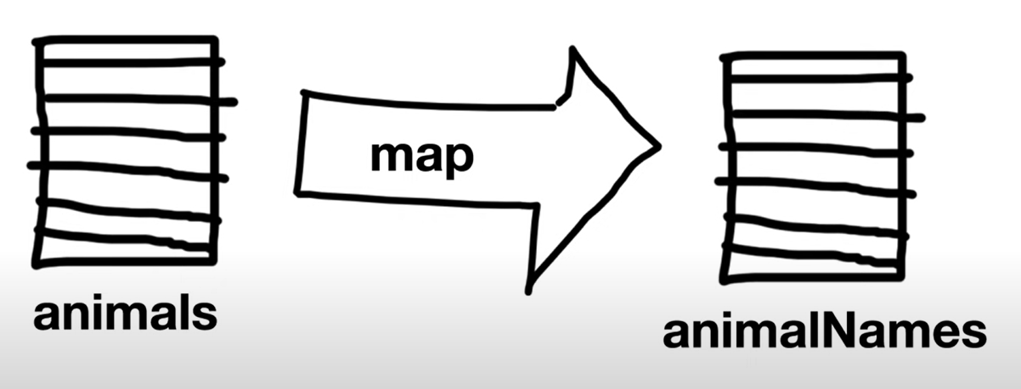

This is what map does it takes an array and displays the array but with each individual item transformed.

Filter transforms an array into smaller array

Does the same thing as filters but inverted

What find does the same thing as filters but only returns the first item so that transforms an array into a single item.

**Reduce**

var orders = [

{ amount: 250 },

{ amount: 400 },

{ amount: 100 },

{ amount: 325 }

]

var totalAmount = 0

// for loop

for (let i = 0; i < orders.length; i++) {

totalAmount += orders[i].amount

}

//reduce method

var totalAmount = orders.reduce(function (sum, order) {

return sum + order.amount

}, 0)